**TO SUPPLY LEFTOVER FOOD TO POOR**

**College Name :** Shree Venkateshwara Arts And Science(co-education)College,Gobi.

**College Code :** BRUBD

**TEAM ID :**

**TEAM MEMBERS :**

**Team** **LeaderName** : Arul prasanth M

**Email :** arulprasanthm2023cs@gmail.com

**Team Member :** Shamimmanuvell L

**Email** : shamimmanuvell2023cs@gmail.com

**Team Member :** Praveen kumar V

**Email :** praveen612525@gmail.com

**Team Member :** Prakash P

**Email :** [prakashp2023cs@gmail.com](mailto:soumiyasr2023cs@gmail.com)

**INTRODUCTION:**

The "To Supply Leftover Food To Poor" project was conceived to address the issue of food wastage and hunger. The goal was to create a system within Salesforce that could efficiently connect sources of leftover food (restaurants, cafeterias, events) with organizations and volunteers who distribute food to those in need. This report details the project's objectives, methodology, implementation, outcomes, and future recommendations.

**PROJECT OVERVIEW:**

Food waste is a global issue, yet millions go hungry every day. FOOD CONNECT aims to tackle this problem by:

* Creating a digital platform using Salesforce for food donation logistics.
* Connecting venues with surplus food to drop-off points via dedicated volunteers.
* Streamlining task assignments and tracking execution details.

### ****SCOPE OF THE PROJECT****

* Collecting leftover food from restaurants, events, and households.
* Sorting, checking for quality, and ensuring food safety.
* Packaging and distributing food to identified needy individuals or shelters.
* Maintaining records of food collection, distribution, and donor contributions.
* Raising awareness about food conservation and community responsibility.

**Key Features Supporting the Project**

* **Food Waste Reduction :**

Diverts surplus edible food from landfills, reducing environmental pollution and conserving resources.

* **Nutrition Support :**

Provides balanced and nutritious meals to underprivileged and vulnerable populations, improving their health and well-being.

* **Community Engagement :**

Involves restaurants, individuals, NGOs, and volunteers, promoting a sense of social responsibility and empathy.

* **Cost-Effective Model :**

Utilizes food that would otherwise go to waste, making the project financially sustainable with minimal cost for meal preparation.

* **Health & Safety Compliance :**

Ensures food safety through proper inspection, packaging, and distribution methods, preventing health risks.

**ROLES**

**Project Manager / Coordinator**

* Oversees the entire operation.
* Plans schedules, allocates tasks, and ensures goals are met.
* Maintains relationships with donors and stakeholders.
* Prepares reports and ensures compliance with safety standards.

**Health & Safety Advisor**

* Provides guidance on proper food handling procedures.
* Ensures adherence to government regulations and health guidelines.
* Offers training sessions on emergency responses and sanitation practices.

**Detailed Description of Implemented Features**

**Salesforce Developer Account Creation**

* To sign up for a salesforce account
* To login to your salesforce account
* Account activation

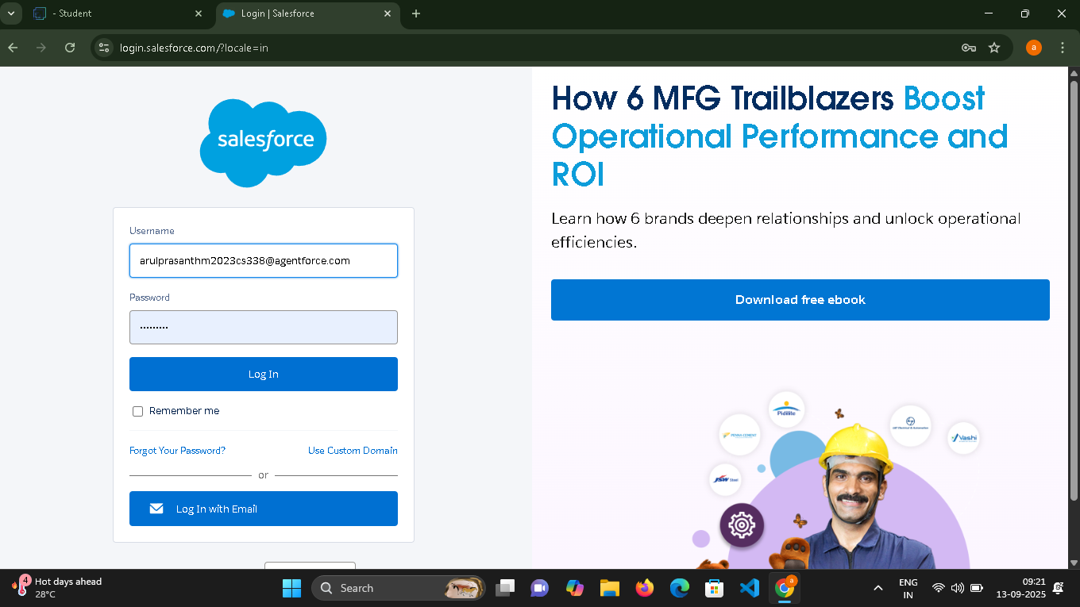

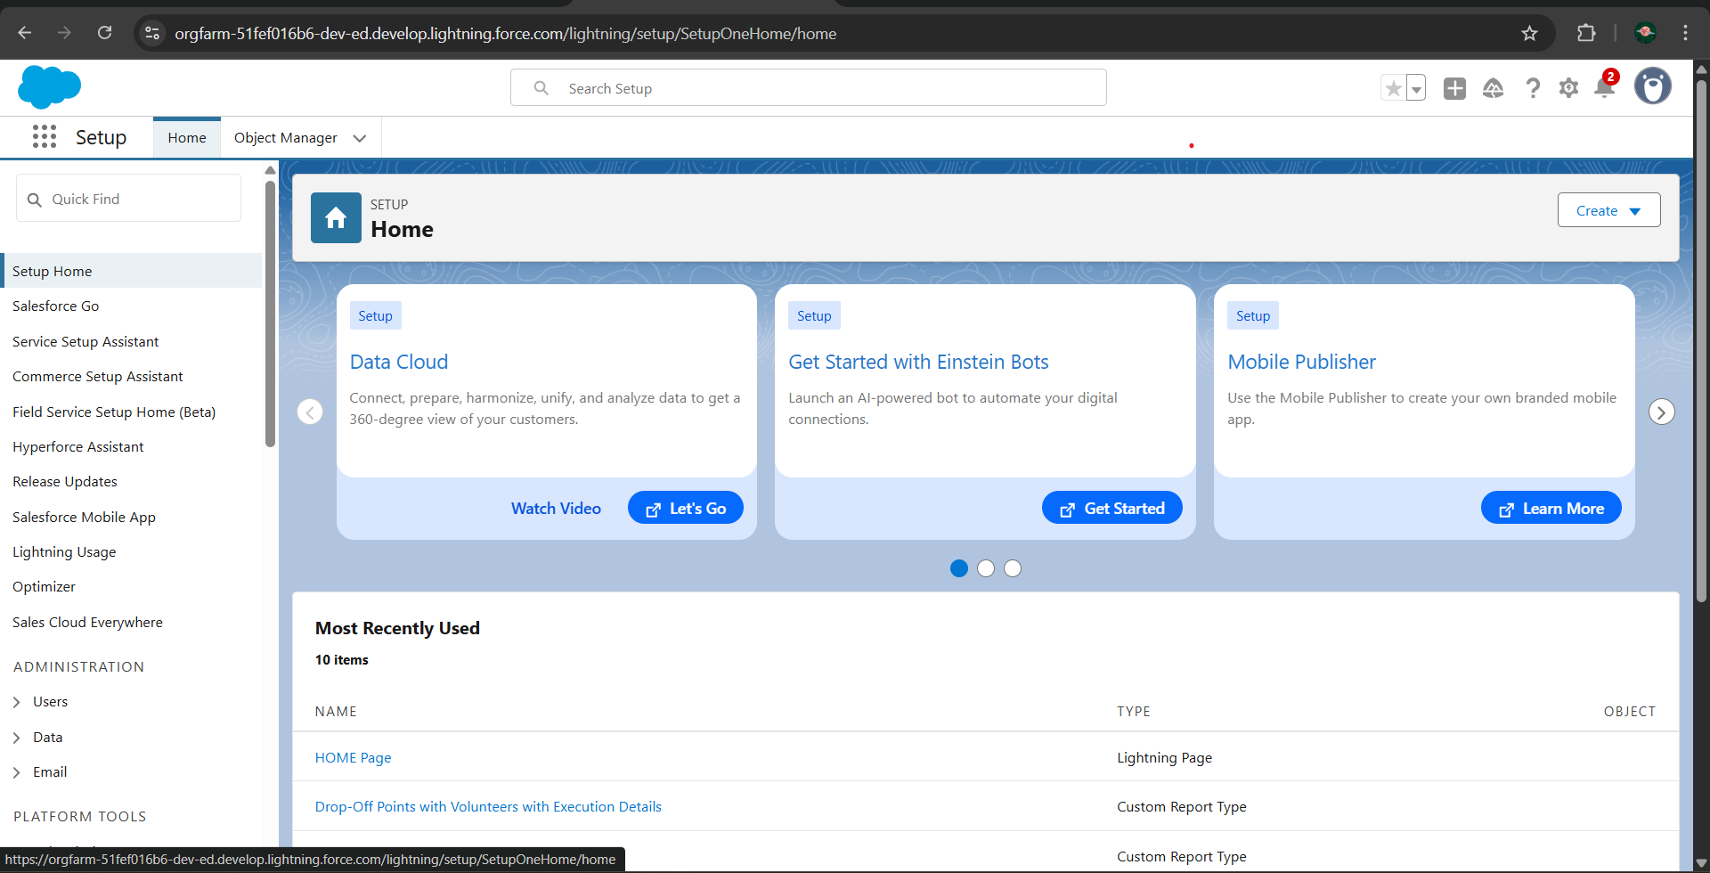

**Object Creation**

**Venue:**

Stores information about locations where leftover food is collected or stored before distribution, including details like address, contact person, and facility capacity.

To create an object:

From the setup page >> Click on Object Manager >> Click on Create >>Click onCustom Object.

* Enter the label name >>Venue
* Plural label name >> Venues
* Enter Record Name Label and Format
* Record Name >> Venue Name
* Data Type >> Text
* Click on Allow reports and Track Field History, Allow Activities.
* Allow search >> Save.

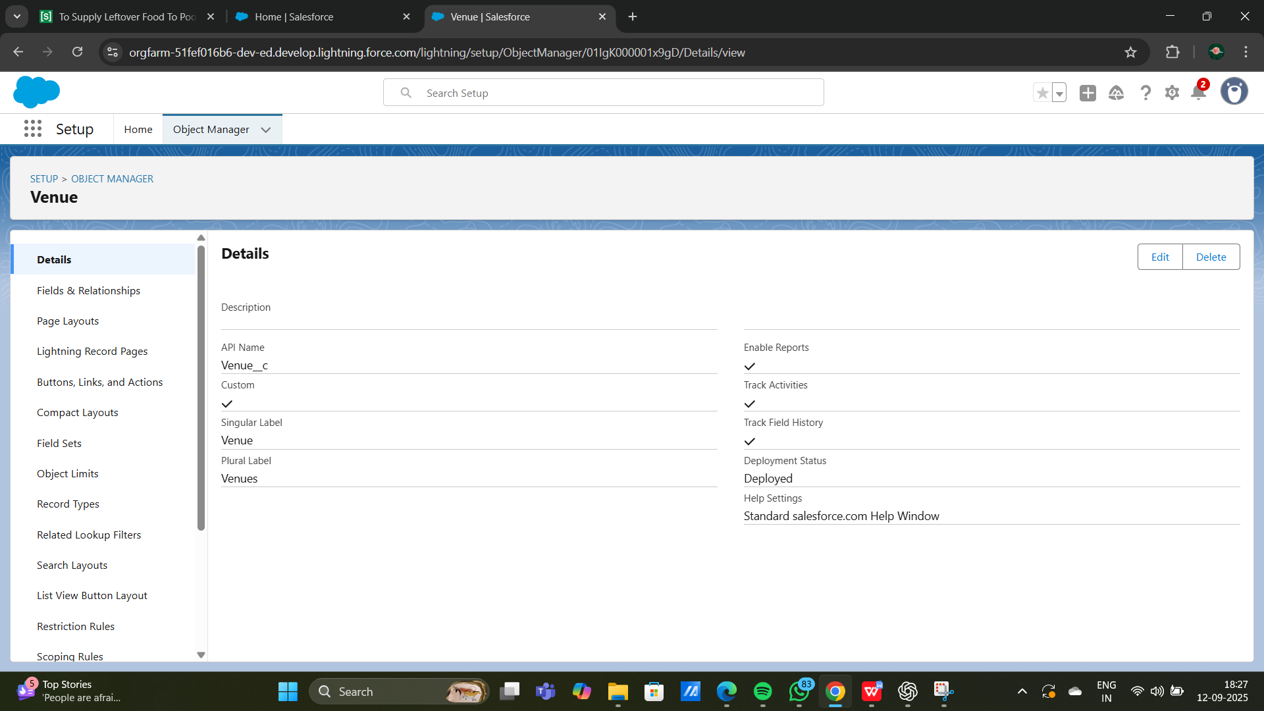

**Task:**

Logs specific tasks related to food collection, transportation, and distribution, assigned to volunteers or teams, ensuring accountability and tracking completion status

**To create an object:**

From the setup page >> Click on Object Manager >> Click on Create>> Click on Custom Object.

1. Enter the label name>>Task

2. Plural label name>> Tasks

3. Enter Record Name Label and Format

Record Name >> Task Name

Data Type >> Text

4. Click on Allow reports and Track Field History, Allow Activities

5. Allow search >> Save.

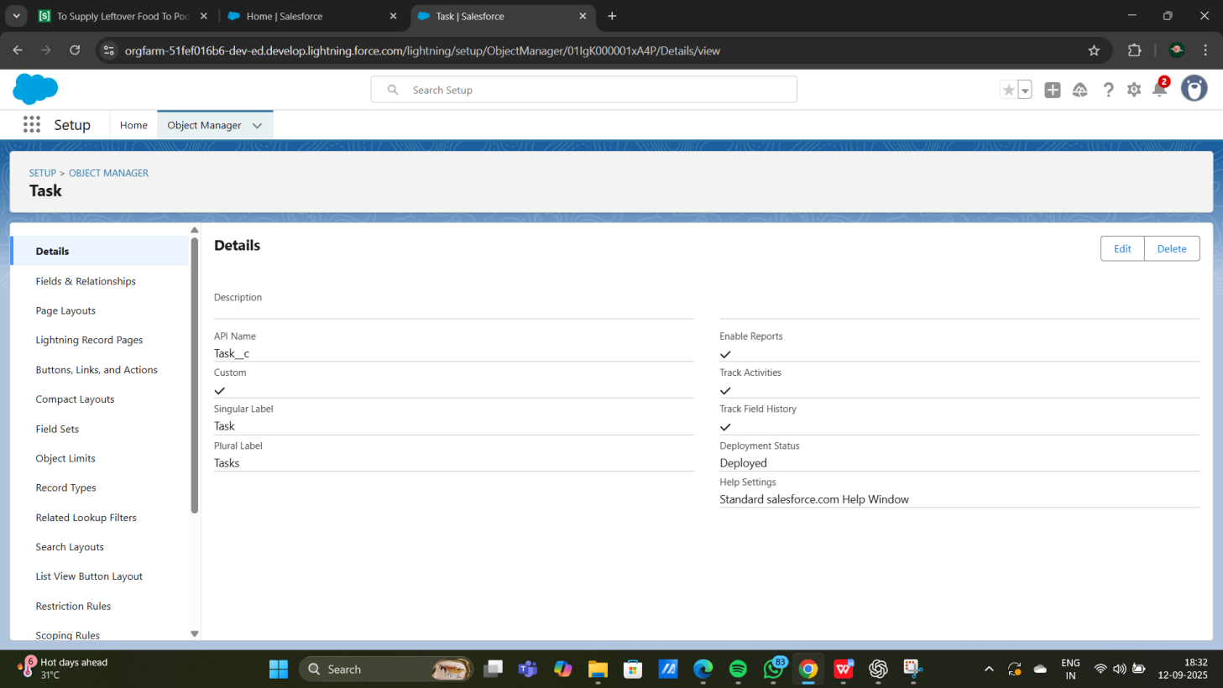

**Volunteer:**

Manages information about the volunteers, including availability, assigned roles, and contact details, to ensure effective communication and task delegation.

**To create an object:**

From the setup page >> Click on Object Manager>> Click on Create >> Click on Custom Object.

1. Enter the label name>> Volunteer

2. Plural label name>> Volunteers

3. Enter Record Name Label and Format

Record Name >> Volunteer Name

Data Type >> Text

4. Click on Allow reports and Track Field History, Allow Activities

5. Allow search >> Save

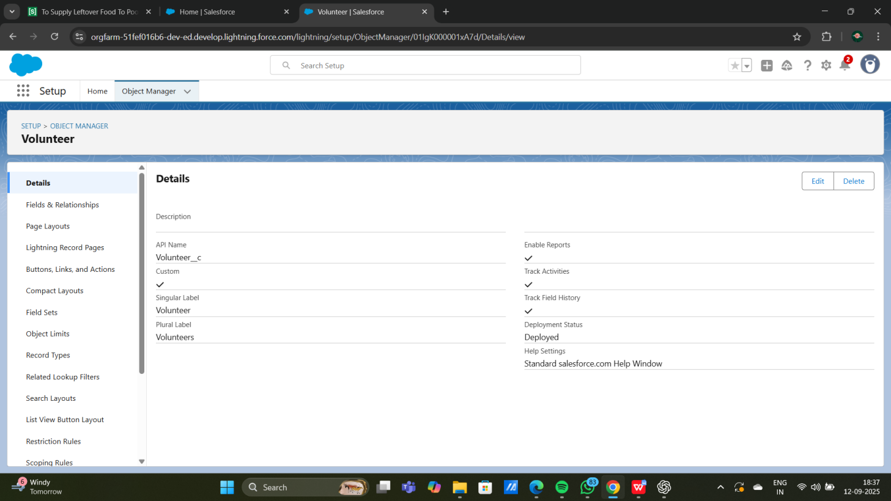

**Execution Details:**

Captures key information about each distribution event, including date, time, food type, and quantity, allowing for efficient planning and tracking of each distribution.

**To create an object**:

From the setup page >> Click on Object Manager >> Click on Create >> Click on Custom Object.

1. Enter the label name >> Execution Detail

2. Plural label name >> Execution Details

3. Enter Record Name Label and Format

Record Name >> Execution Detail Name

Data Type >> Text

4. Click on Allow reports and Track Field History, Allow Activities

5. Allow search >> Save

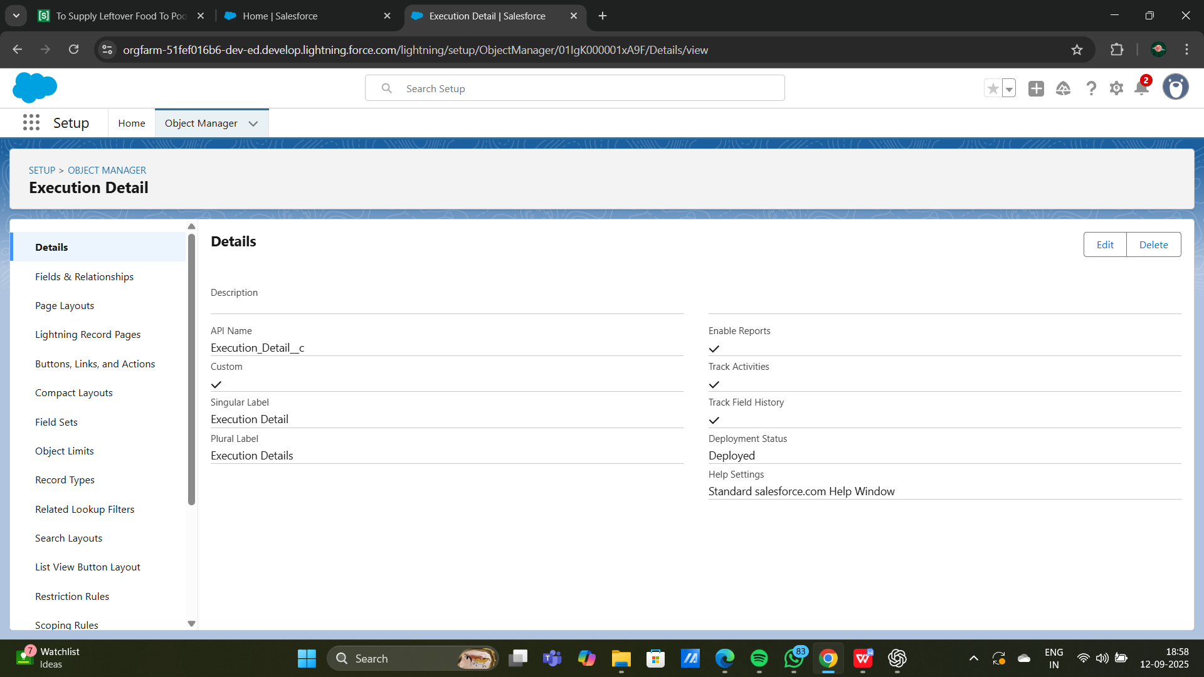

**Drop-Off Point:**

This object records information about specific locations where food donations are delivered for distribution.

**To create an object:**

From the setup page >> Click on Object Manager >> Click on Create >> Click on Custom Object.

1. Enter the label name >> Drop-Off Point

2. Plural label name>> Drop-Off Points

3. Enter Record Name Label and Format

Record Name >> Drop-Off point Name

Data Type >> Text

4. Click on Allow reports and Track Field History, Allow Activities

5. Allow search >> Save.

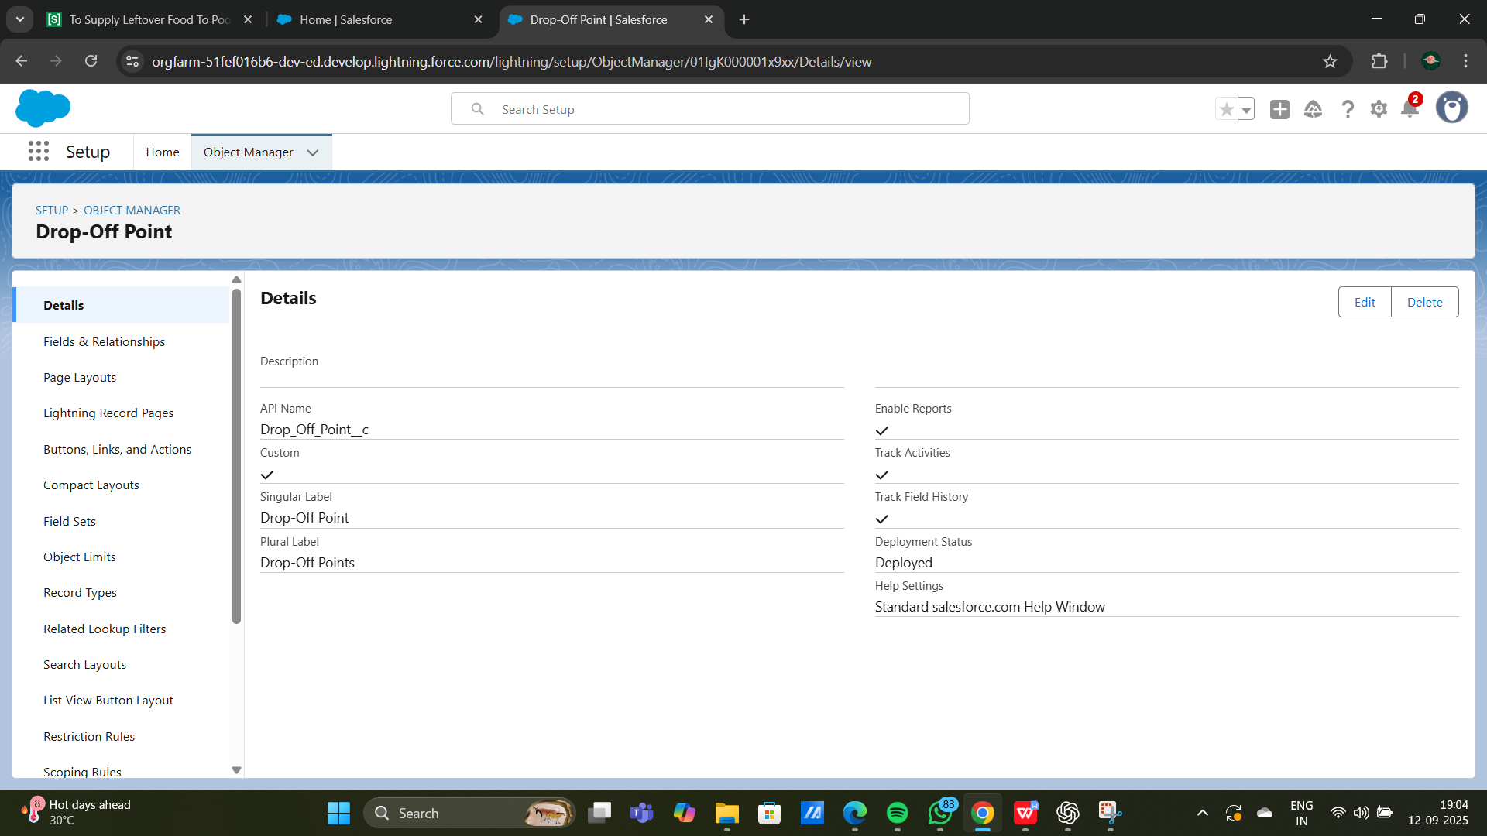

**Tabs**

In Salesforce, tabs are used to display and organize data for specific objects and functions within an application, making it easier to navigate and manage information. For your project, tabs will represent each key object-like Venue, Drop-Off Point, Execution Details, Volunteer, and Task-allowing users to quickly access, view, and update records.

**Types of tabs in salesforce**

* **Standard Object Tabs:** These display data for Salesforce's built-in objects (e.g.,Accounts, Contacts).
* **Custom Object Tabs:** These tabs display data for custom objects you've created, such as Venue, Drop-Off Point, Execution Details, Volunteer, and Task in your project.
* **Web Tabs:** These display an external website within Salesforce, useful if you need access to online tools directly in your app.
* **Visualforce Tabs:** These display data from a Visualforce page, allowing for customized Ul and functionality beyond standard Salesforce capabilities.

**Creation of Custom tabs**

**To create a custom tab for each of your project's objects, follow these steps:**

1. **Log in to Salesforce:** Ensure you're logged in with administrator privileges.

2. **Access Setup:** Click the gear icon in the top-right corner and select "Setup."

3. **Navigate to Tabs:** In the Quick Find box, type "Tabs" and select "Tabs" from the list.

4. **Create New Custom Object Tab:**

* Click New next to "Custom Object Tabs."
* Select the Object for the tab (e.g., Venue, Drop-Off Point, Execution Details, Volunteer, or Task).
* Choose a Tab Style (an icon that represents the tab visually).

5. **Tab Label and Visibility:**

* Enter a Label for the tab that will appear to users (e.g., "Venue" for the Venue object).
* Select Profiles to determine which users will have access to this tab.

6. **Save and Organize:**

* After saving, add the tab to the relevant App (e.g., your project's custom app for food distribution) so it's accessible within the application.
* Use App Manager to arrange the tabs in your preferred order.

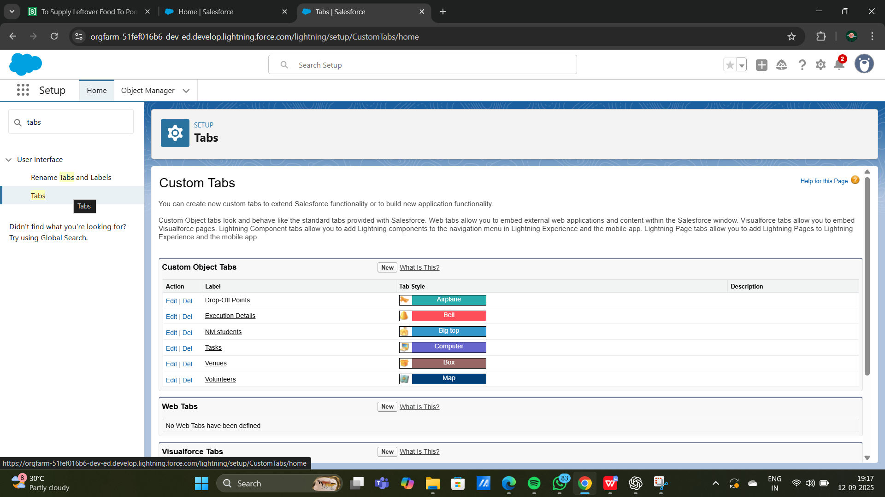

**Lightning apps**

Lightning Apps in Salesforce consist of a set of tabs and components that work together to enable specific functions. They have a name, logo, and a customizable set of tabs. There are two types of Salesforce applications:

1. Standard Apps: Default apps that come with Salesforce (e.g., Sales, Marketing, Chatter).

2. Custom Apps: Tailored apps with selected standard and custom tabs to meet specific needs.

**creation of lightning apps**

* **Access App Manager:**In Salesforce Setup, type "App Manager" in the Quick Find box and select it.
* **Create a New Lightning App**:Click on "New Lightning App" and enter the app name (e.g., "Food Supply Management").
* **Configure App Options:** Set the app's visibility, logo, branding, and any custom settings. Keep the default settings if not specified.
* **Utility Bar (Optional):** Add tools like Notes or Chat to the app's utility bar if needed
* **Select Tabs:** Choose the objects and tabs you want to include, such as "Venue," "Drop-Off," "Execution Details," "Volunteer," and "Task" for a food distribution app.➤
* **Assign Profiles:** Specify which user profiles can access the app by moving relevant profiles (e.g., System Administrator) to "Selected Profiles."
* **Save and Launch:** Click "Save & Finish" to complete setup. Access the app through the App Launcher to verify that all tabs and settings appear correctly.

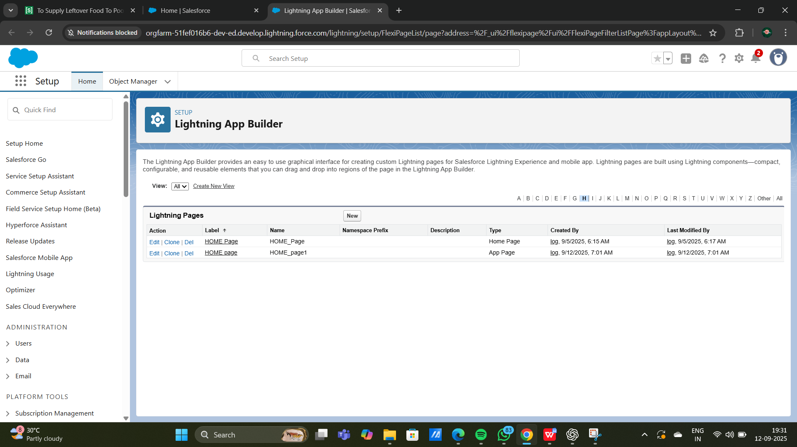

**FIELDS**

To structure your Salesforce app for a food distribution project, you need to create objects and define fields to capture and manage data effectively. Here's a detailed guide on setting up fields, relationships, and creating key objects like Venue, Drop-Off Point, Task, Volunteer, and Execution Details.

**creating fields and relationship fields in object**

* Standard Fields: These are predefined by Salesforce, like "Name" and "Created Date."
* Custom Fields: Add fields to capture specific information for each object.
* Relationship Fields:
* Lookup Relationship: Links two objects loosely, allowing null values.
* Master-Detail Relationship: A tighter link where the child object
* depends on the parent, inheriting permissions and sharing settings.

**Creating Relationships:**

**In Setup**, go to the **Object Manager**.

* Open the object where you want to add a relationship field.
* Select Fields & Relationships, then New.

**Choose the type of relationship field:**

* For Lookup, select another object to link.
* For Master-Detail, select the parent object.
* Set field visibility, add help text, and save.

**Creating key objects for fields**

**a. Venue Object**

**Purpose:** To store locations where food is available for pickup.

**Key Fields:**

* **Venue Name (Text):** Name of the venue.
* **Address (Text Area):** Detailed address of the venue.
* **Contact Number (Phone):** Venue's contact information.
* **Capacity (Number):** Maximum amount of food that can be stored at this venue
* **Venue Type (Picklist):** Options like "Restaurant," "Event Hall," or "Catering Service."
* **Status (Picklist):** Indicates availability (e.g., Available, Closed).

**Relationships:**

* **Related to Drop-Off** (Lookup or Master-Detail with Drop-Off Point): Shows available drop-off points for each venue.

**b. Drop-Off Point Object**

* **Purpose:** To track locations where food is delivered.

**Key Fields**:

* **Drop-Off Location Name** (Text): Name of the drop-off point.
* **Distance** (Number): Distance from the venue to drop-off point.
* **Address** (Text Area): Detailed address.
* **Operational Hours** (Text): Hours during which drop-off is accessible

**Relationships:**

* Linked Venue (Lookup or Master-Detail with Venue): Connects each drop-off point to a specific venue for reference.

**c. Task Object**

**Purpose:** To track tasks associated with food collection and delivery.

**Key Fields:**

* **Task Name** (Text): Brief name of the task.
* **Description** (Text Area): Details about the task.
* **Assigned Volunteer** (Lookup with Volunteer): Assigns a volunteer to each task.
* **Due Date** (Date): When the task needs to be completed.
* **Priority** (Picklist): Options like High, Medium, Low.

**Relationships:**

* **Related Venue or Drop-Off** (Lookup): Links tasks to specific venues or drop-off points as needed.

**d. Volunteer Object**

* **Purpose:** To manage volunteer details.
* **Key Fields:**

**Volunteer Name** (Text): Full name of the volunteer.

**Contact Information** (Phone): Phone number of the volunteer.

**Email** (Email): Volunteer's email address.

**Availability** (Picklist): Options like "Available," "Not Available," "Part-Time."

* **Relationships:**

**Assigned Tasks** (Master-Detail or Lookup with Task): Link

**Associated Venues** (Lookup or Master-Detail with Venue): Allows linking volunteers to specific venues if needed.

**e. Execution Details Object**

* **Purpose:** To record details of each food delivery event.

**Key Fields:**

**Execution Name** (Text): Name of the execution event.

**Start Date** (Dote): Start date of the event.

**End Date** (Date): Completion date.

**Total Food Distributed** (Number): Quantity of food distributed.

**Volunteers Involved** (Lookup with Volunteer): Record of volunteers who participated.

**Challenges Encountered** (Text Area): Brief description of any issues faced.

* **Relationships:**

**Venue and Drop-Off Link** (Lookup with Venue and Drop-Off): Links the execution details with specific venues and drop-off points.

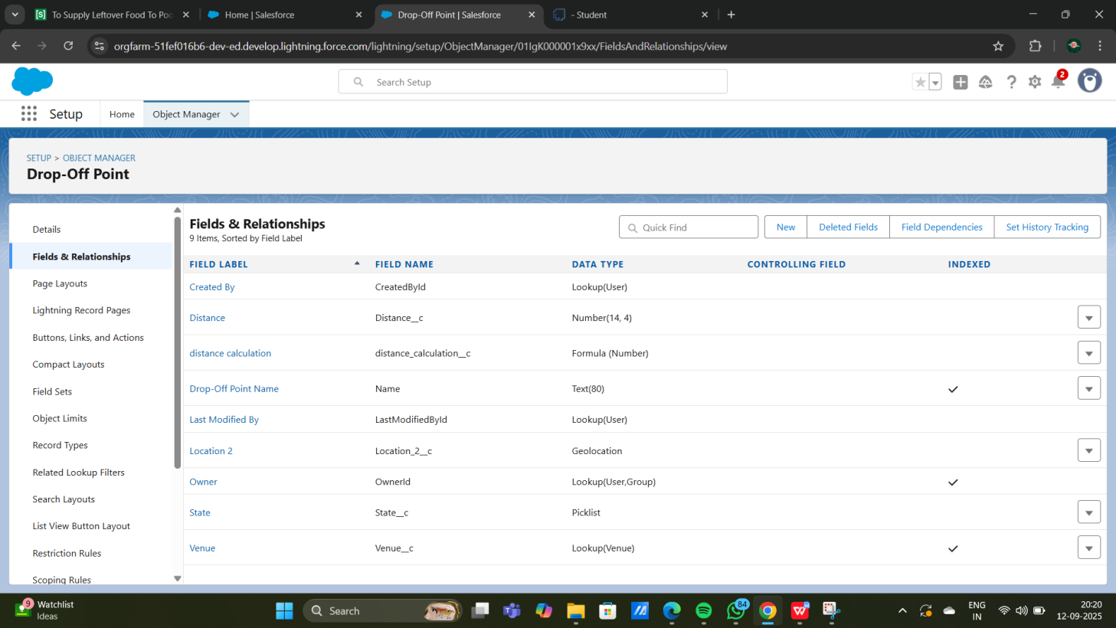

**Flows**

In Salesforce, Flows are powerful automation tools that can automate processes such as record creation, updates, notifications, and complex logic. Here's an overview of creating flows, and then specifically, setting up a flow to create a record in the Venue object.

* **Screen Flows:** Used for guided user input; can be used on pages.
* **Record-Triggered Flows:** Automatically trigger on record creation, updates, or deletions.
* **Scheduled Flows:** Run on a set schedule to perform routine tasks.
* **Platform Event-Triggered Flows:** Triggered by platform events for real-time integration.

**Steps to Create a Flow to Add a Venue Record**

**1. Start a New Flow**

* Go to **Setup** in Salesforce, type **Flows** in the Quick Find box, and select Flows.
* Click New Flow.
* For this task, select Screen Flow if you want user input for creating a Venue record or Record-Triggered Flow if it should automatically create Venue records under specific conditions.

**2. Configuring the Flow**

**Screen Flow Setup:**

* **Step 1:** Drag a Screen element from the Toolbox on the left.
* **Step 2:** On the screen, add fields that users will fill out, such as
* Venue Name, Address, Contact Number, Capacity, and any other relevant fields.
* **Step 3:** Set component types to match field data (e.g., Text, Phone, Number, Picklist).

**Record-Triggered Flow Setup:**

* Step 1: In Trigger the Flow When, select A record is created.
* Step 2: Choose the object and specify any criteria that should trigger the record creation.

**3. Adding the Create Record Element**

* Click + Add Element in the flow canvas and select Create Records.
* Label the action, for example, "Create Venue Record."
* Select the Venue Object: Choose Venue as the object where the record will be created.

**4. Define the Field Values**

* Map the fields in the Venue object to the corresponding input fields or variables:
* **Venue Name:** Map to the name input provided by the user orpredefined value.
* **Address:** Link to a text input field.
* **Contact Number:** Map to the phone input field.
* **Capacity:** Map to the number input field.
* **Choose Fields and Set Values:** Ensure that required fields are mapped.

**5. Save and Activate the Flow**

* Click Done to save the element setup.
* Save the Flow with a descriptive name, such as "Create Venue Record Flow."
* Activate the flow by clicking Activate in the Flow Builder toolbar.

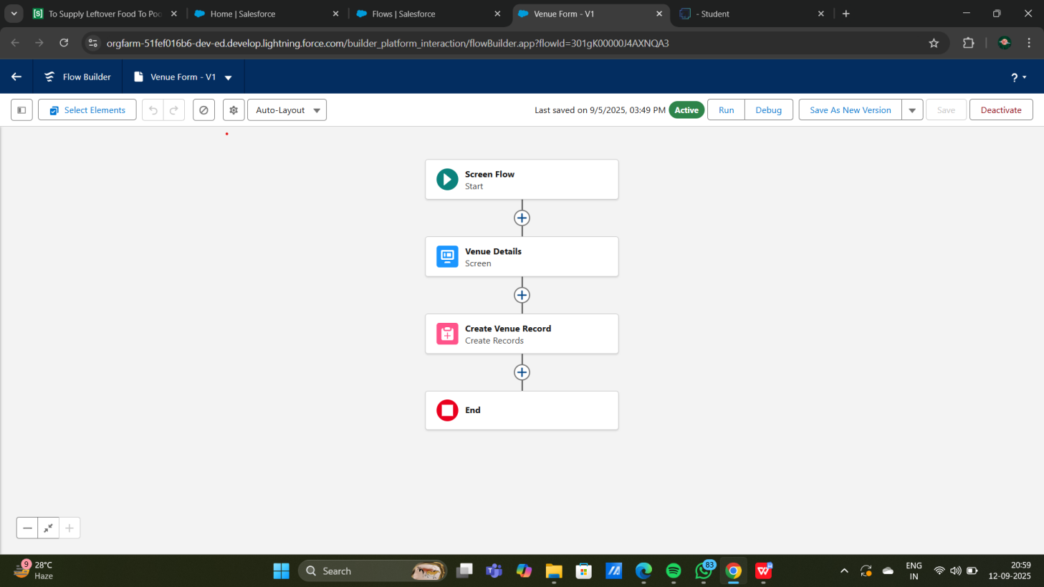

**Testing And Validation**

**Trigger**

To create a trigger in Salesforce that automatically creates a record in the Venue object based on a specific condition or event, you'll need to write an Apex Trigger. Here's a step-by-step guide, along with an example trigger.

**Steps to Create a Trigger in Salesforce**

1. **Access Developer Console:**

* In Salesforce, click the Gear Icon () and select Developer Console.

**2.** **Create a New Trigger:**

* In the Developer Console, go to File > New > Apex Trigger.
* Choose the object you want the trigger to be associated with. For instance, if you want the trigger to create a Venue record when a Task record is created, select the Task object.
* Name the trigger (e.g., CreateVenueOnTaskTrigger).

**3.Define the Trigger Logic:**

* Define when the trigger should fire, such as before insert or after insert.
* Specify the actions the trigger will take, such as creating a new Venue record.

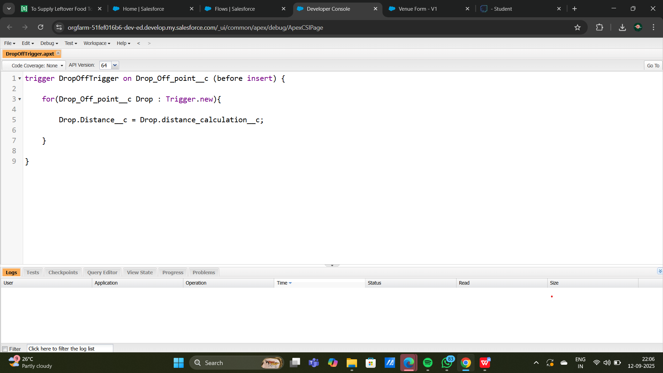

**Profiles**

In Salesforce, Profiles are crucial for controlling user access to data, objects, and specific features within your app. Profiles define user permissions, such as object permissions, field-level security, app settings, and more. Here's a guide to creating and configuring profiles for your project.

1. **Standard Profiles:** Predefined by Salesforce with fixed permissions (e.g., System Administrator, Standard User).

2. **Custom Profiles:** Created to provide specific permissions tailored to the needs of your project. Custom profiles allow you to control access at a more granular level

**Steps to Create and Configure Profiles in Salesforce**

**1. Accessing Profiles**

* + - * In Setup, type Profiles in the Quick Find box and select Profiles.
      * You will see a list of existing profiles, including both standard and custom profiles.

**2. Creating a New Profile**

* To create a custom profile, you can either clone an existing profile or start from scratch.
* **Clone a Profile:**
* Select a standard profile (like "Standard User") that closely matches the permissions you need.
* Click Clone to create a new profile based on this existing profile.

**3. Configuring Profile Settings**

* **Profile Name:** Name your profile, e.g., "Venue Manager" or "Volunteer Coordinator".
* **Object Permissions:**
* Scroll down to Custom Object Permissions.
* For each custom object (e.g., Venue, Drop-Off Point, TaskRead: Allows viewing records.
* **Read:** Allows veiwing records.
* **Create:** Allows creating new records.
* **Edit**: Allows editing existing records.
* **Delete:** Allows deleting records.
* For example, a "Venue Manager" profile might have full access to the Venue object but limited access to other objects.

**Field-Level Security:**

* + - * Go to each custom object and specify Field-Level Security for each field,
      * Set fields to Read-Only or Hidden if certain data should not be edited or viewed by this profile.

**NAME OF PROFILE:**

* Go to setup page >> type Profiles in Quick Find bar >> click on Profiles >> click on ‘S’
* Click on Clone beside Standard Platform User.
* Under Clone Profile:
* Profile Name : NGOs Profile
* Then click on Save

\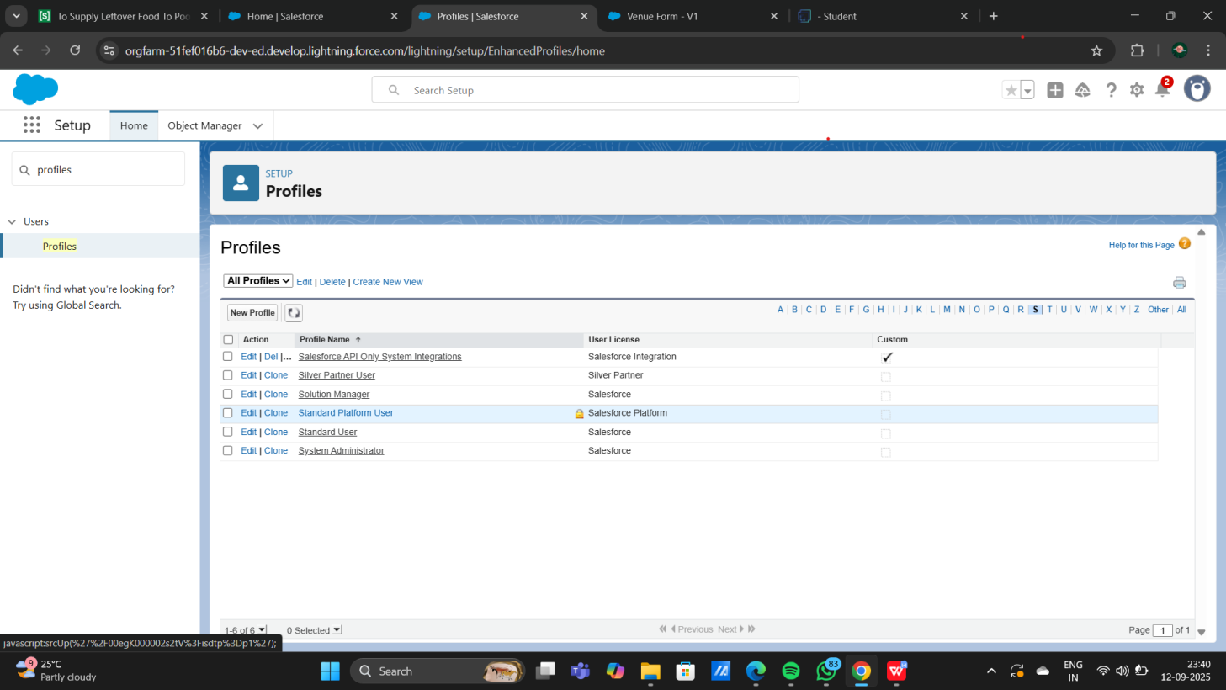

### Creation of User 1

1. Go to setup page >> type users in Quick Find bar >> click on users>> New user.
2. In General Information give details as: (Note : create users as per your wish NGO’s)

First Name : Iksha Foundation

Last Name : Iksha_Foundation

Alias : iiksh

Email : Give Your Email

Username : [ikshafoundation@sb.com](mailto:ikshafoundation@sb.com) (give the username different)

Nickname : Auto Populated

User License : Salesforce Platform

Profile : NGOs Profile

Active : Check

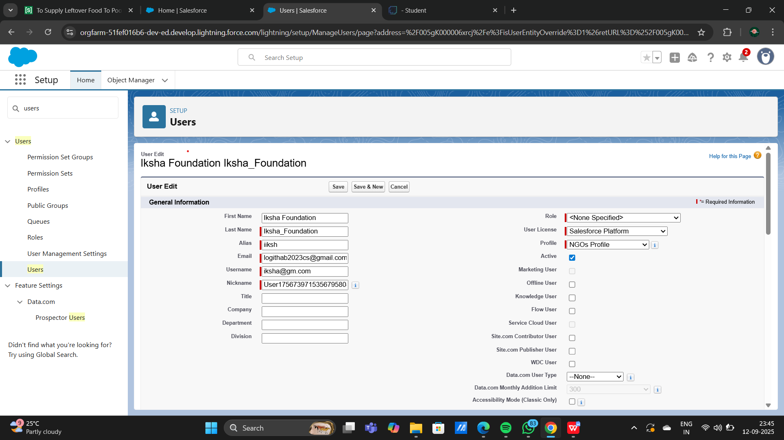

### Creation of User2, User3

1. Create another Two Users by following steps in Activity - 1 with similar User License and Profile.
2. Give Different First Name, Last Name based on Different NGO’s.

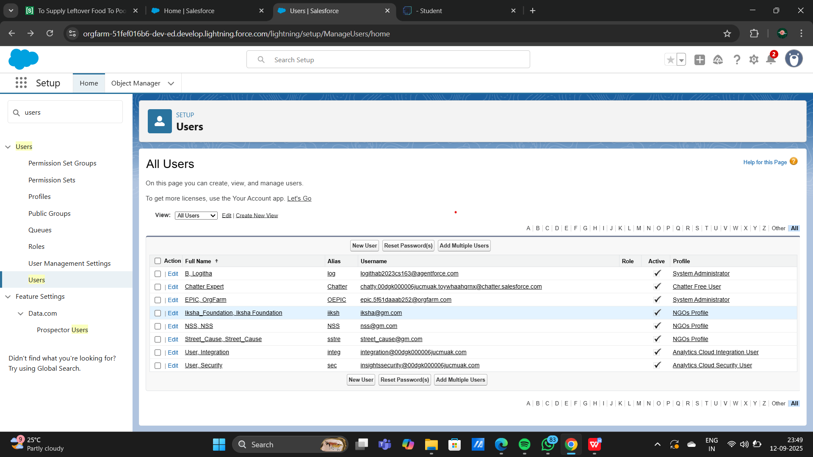

### Creation of Public Group 1

1. Go to setup page  >>  type Public Groups in Quick Find bar  >>  click on Public Groups >>  click on New.
2. Under Group Information:

Label : Iksha

Group Name : Iksha

Grant Access Using Hierarchies : Check

1. In Search, Select Users.
2. In Selected Members Add Iksha Foundation and System Administrator

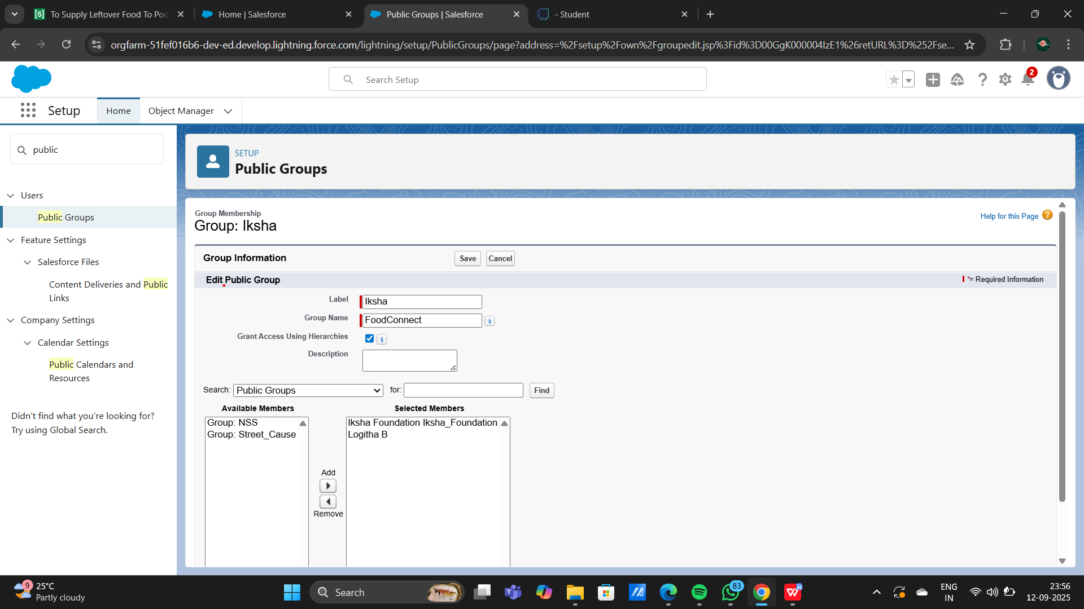

### Creation of Public Group 2

1. By Following Steps in Activity 1, Create other  two Public Groups for other two users.
2. After Saving this would look like this.

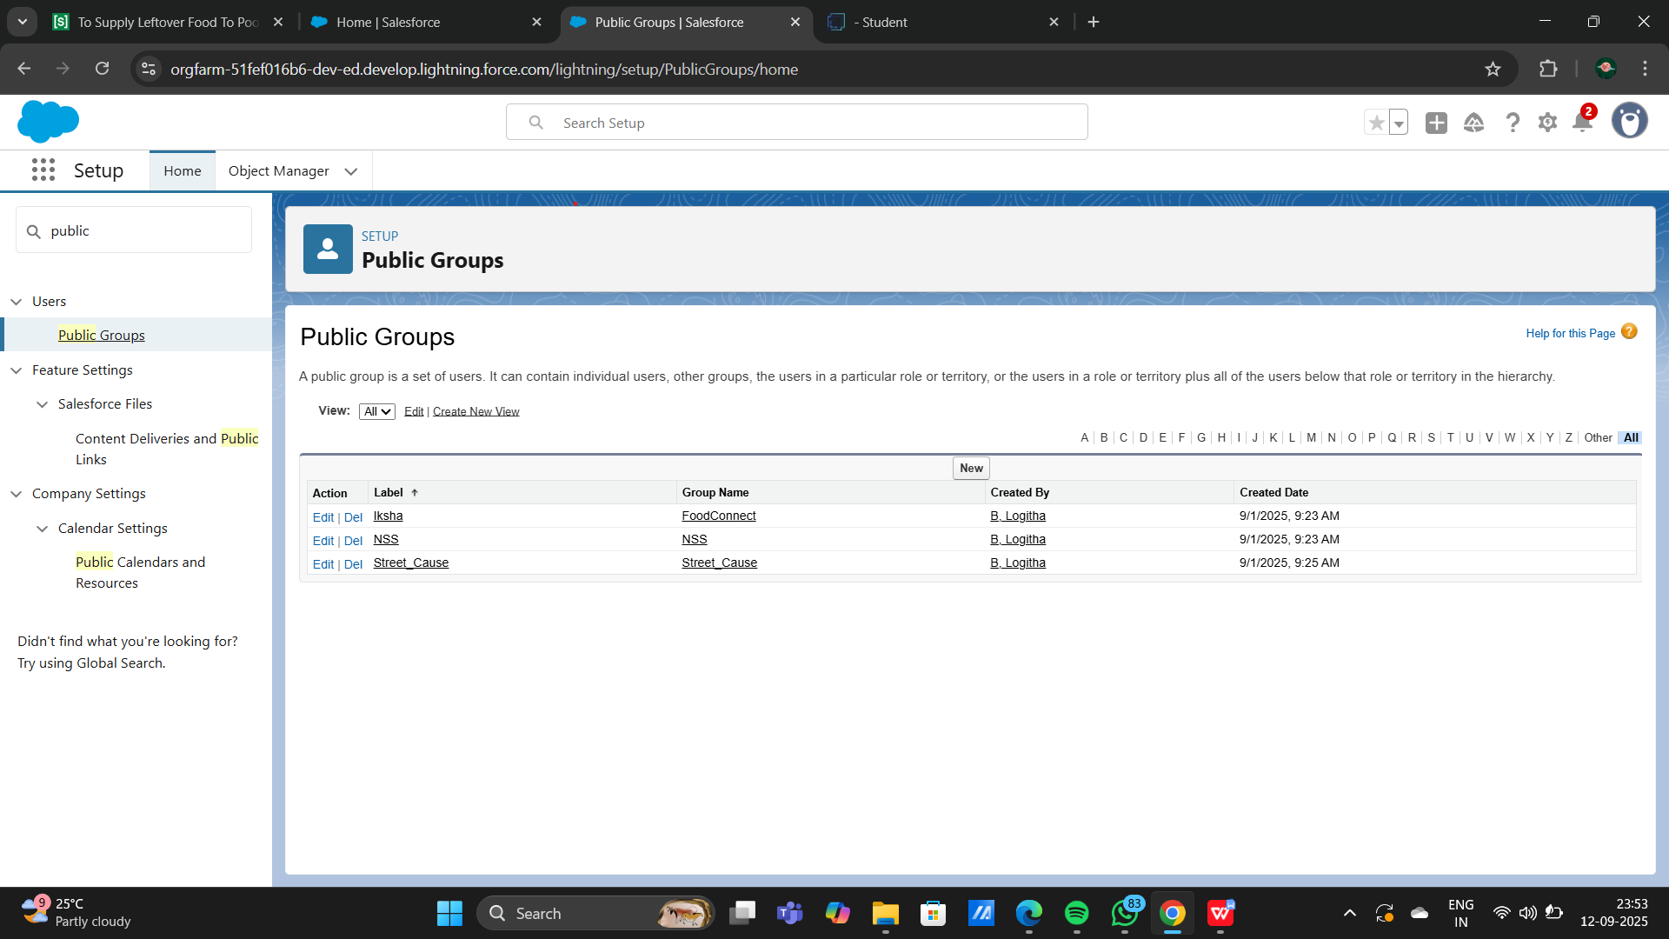

**Report types**

In Salesforce, Report Types define the set of data and relationships that reports can access. By customizing report types, you can tailor them fit your project needs, such as tracking venue usage, volunteer participation, or task completion for your food distribution project.

### Creation of Report Types

1,Go to setup page  >>  type Report Types in Quick Find bar  >> click on Report Types  >>  click on Continue   >>  Click on New Custom Report Type.

2.In Define the Custom Report Type:

Primary Object : Select Venues

Report Type Label : Venue with DropOff with Volunteer

Report Type Name : Venue_with_DropOff_with_Volunteer

Description : Venue with DropOff with Volunteer

Store in Category : Select Other Reports

Deployment Status : Deployed

1. Click on Next
2. Near Click to relate another Object Select Drop-Off Points.
3. And also select "A" records may or may not have related "B" records.
4. Now again Near Click to relate another Object Select Volunteers.
5. Now click on Save.

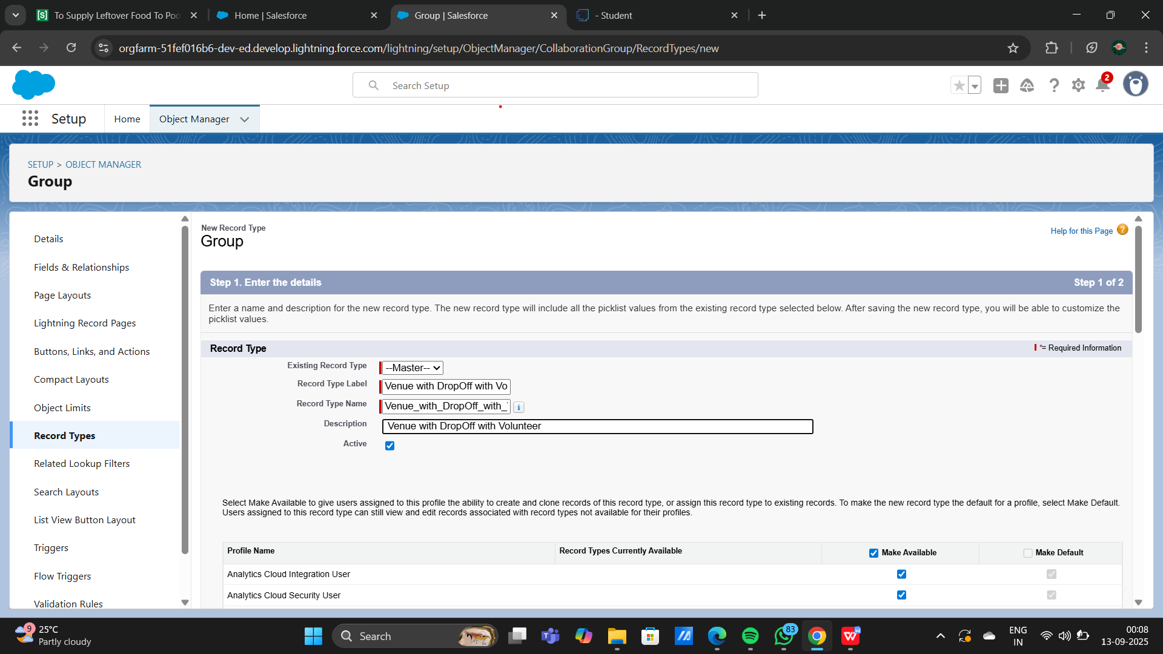

### Creation of Report on Venue with DropOff with Volunteer

1.Go to the app(FoodConnect)  >>  click on the reports tab

2.Click on New Folder.

Folder Label : Custom Reports

Folder Unique Name : CustomReports

3.Open Custom Reports and click on New Report

4.Select Report Type : Venue with DropOff with Volunteer

5.Then click on Start Report

6.In GROUP ROWS : Add Volunteer Name

7.In Columns : Add Venue Name, Drop-Off point Name, Distance.

8.Now click on Save & Run.

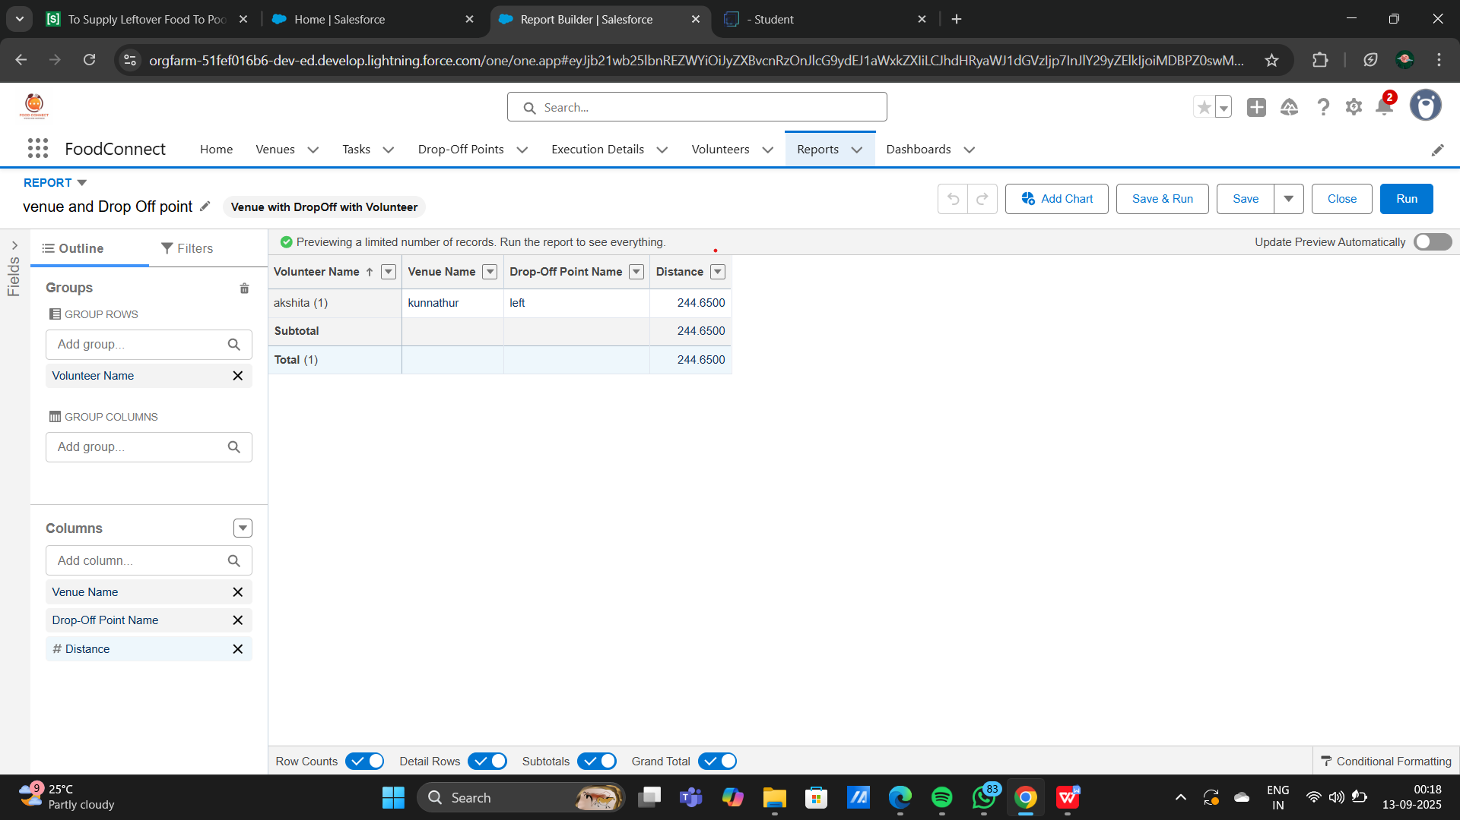

9.Give Label as :

10.Report Name : venue and Drop Off point

11.Report Unique Name : Auto Populated

12.Click on Select Folder and select Custom Report, then click on Save

### Creation of Report on Volunteers with Execution Details and Tasks

1.Go to the app(FoodConnect)  >>  click on the reports tab

2.Click on Custom Reports Folder and click on New Report

3.Select Report Type : Volunteers with Execution Details and Tasks.

4.Then click on Start Report.

5.In GROUP ROWS : Volunteer ID

6.In Columns : Add Volunteer : Volunteer Name, Task : Task Name, Execution Detail : Execution Detail Name, Volunteer: Owner Name, Task: Date, Task : Rating.

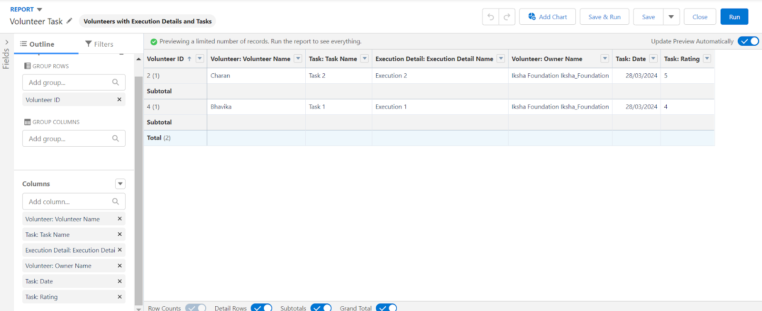

7.Now click on Save & Run.

8.Give Label as :

Report Name : Volunteer Task

Report Unique Name : Auto Populated

9.Click on Select Folder and select Custom Report, then click on Save.

**Dashboard**

In Salesforce, Dashboards are visual representations of data collected from reports, allowing users to monitor key metrics and gain insights at a glance. Dashboards are built using components (e.g., charts, tables, metrics), each representing a report. For your food distribution project, a dashboard could track metrics like the number of active venues, tasks completed by volunteers, and food distributed.

### Adding venue and Drop Off point Report to the Dashboard

1.Go to the app(FoodConnect)  >>  click on the Dashboards tab.

2.Click on New Folder.

Folder Label : Custom Dashboards

Folder Unique Name : Auto Populated

3.Open Custom Dashboards and click on New Dashboards

4.Name : Organization Details

5.Click on Widget and select Chart or Table

6.In Select Report : Select venue and Drop Off point Report.

7.Then click on select

8.In Add Component:

Display As : Select Lightning Table

Component Theme : Select Dark (Optional)

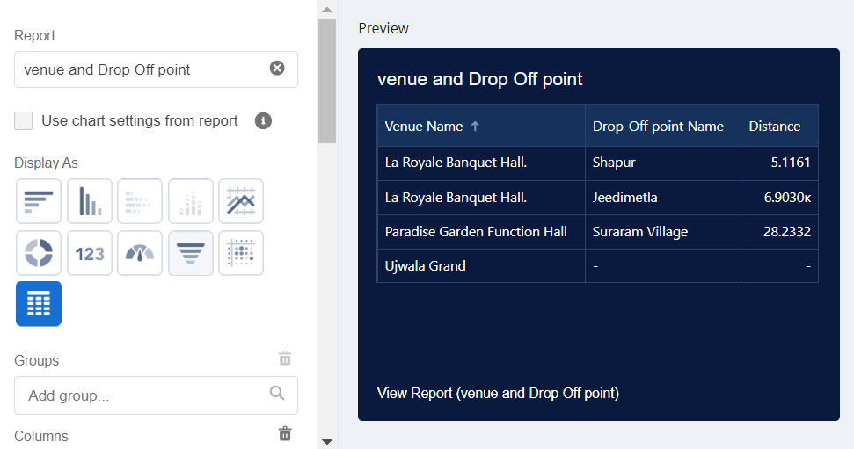

10.Now click on save.

### Adding Volunteer Task Report to the Dashboard

1.Click on Widget and select Chart or Table

2.In Select Report : Select Volunteer Task Report.

3.Then click on select

4.In Add Component:

Display As : Select Line Chart

Component Theme : Select Dark (Optional)

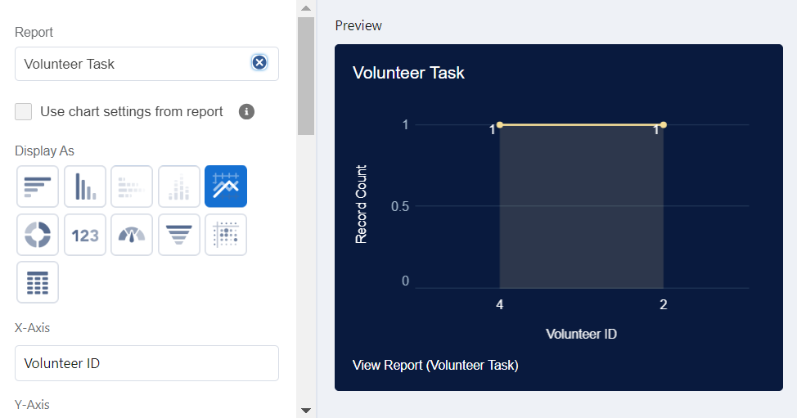

1. Now click on save.

### Adding a Picture to the Dashboard (Optional)

(Note : To upload an image into the Dashboard, we have to first download an image from google or other sources into your system)

1. Click on Widget and select Image. Then click on Browse Files.
2. Then Select the Picture you want to upload in this Dashboard.
3. Then click on Save As :

Name : Task Execution Details

Click on Select Folder and select Custom Dashboards

1. Click on Select Folder and then Save.

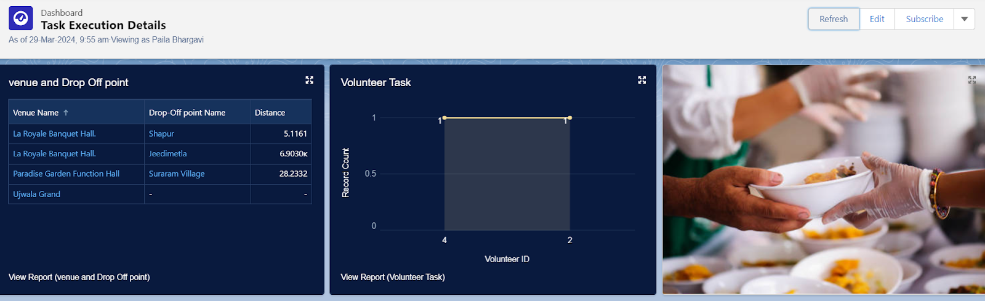

**Sharing rules**

Sharing Rules in Salesforce are used to extend data access to users based on specific criteria, overriding the default Organization-Wide Defaults (OWD). Sharing rules allow you to share records with particular users, roles, or groups based on either ownership or field-based criteria. For your food distribution project, sharing rules can help control access to objects like Venue, Task, Volunteer, and Execution Details, ensuring data is visible to the right people without compromising security.

### Creation of sharing rules

1.Go to setup  >>  type Sharing Settings in quick find box  >>  Click on theSharing Settings.

2.Scroll down and find Drop-Off point Sharing Rules.

3.Click on new near Drop-Off point Sharing Rules and Name it as:

Label : Rule 1

Rule Name : Rule_

4.Select your rule type : Select Based on criteria.

5.Select which records to be shared:

Field : Operator : Value = Distance : less than : 15

6.Select the users to share with : Near Share With

Public Groups : Iksha

7.Click on Save.

8.Click on new near Drop-Off point Sharing Rules and Name it as:

Label : Rule 2

Rule Name : Rule_2

9.Select your rule type : Select Based on criteria.

10.Select which records to be shared:

Field : Operator : Value = Distance : greater than : 15

Field : Operator : Value = Distance : less or equal : 30

11.Select the users to share with : Near Share With

Public Groups : NSS

12.Click on Save.

13.Click on new near Drop-Off point Sharing Rules and Name it as:

Label : Rule 3

Rule Name : Rule_3

14.Select your rule type : Select Based on criteria.

15.Select which records to be shared:

Field : Operator : Value = Distance : greater than : 30

Field : Operator : Value = Distance : less or equal : 50

16.Select the users to share with : Near Share With

Public Groups : Street Cause

17.Click on Save.

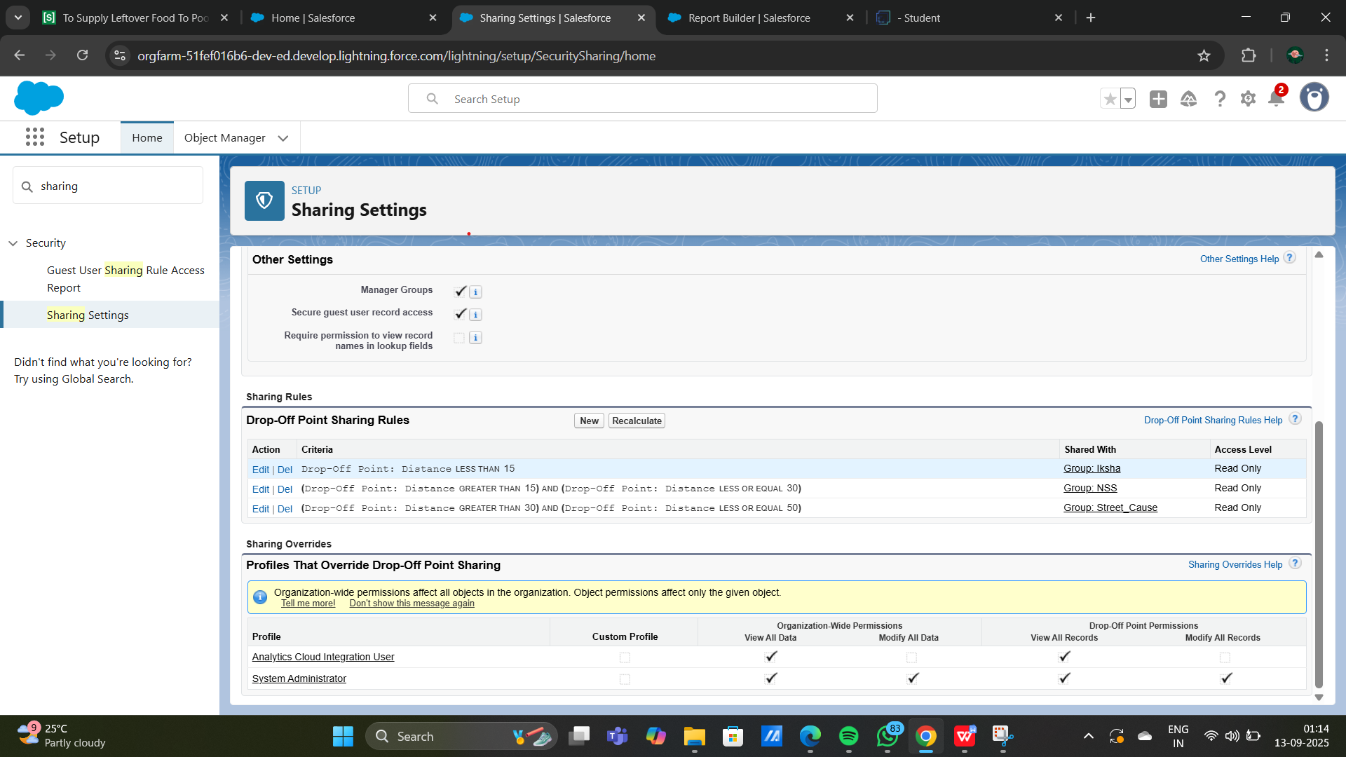

**Homepage**

Creating a Home Page in Salesforce allows you to design a personalized landing page that displays key metrics, quick links, and other components users need when they first log in. For your food distribution project, a custom

Home Page can include components like recent venues, task updates, and volunteer assignments to streamline navigation and increase efficiency.

### Creation of Home Page

1.Go to setup >> type Lightning App Builder in quick find box  >>  Click on the Lightning App Builder and Select the New.

2.Select Home Page and give Label as HOME Page

3.Select Standard Home Page.

4.Near Components search for Flow and Drag and Drop in Right Side Section..

5.On the right hand side:

Flow : Venue Flow

6.Near Components search for Dashboard, then Drag and Drop it in first Section.

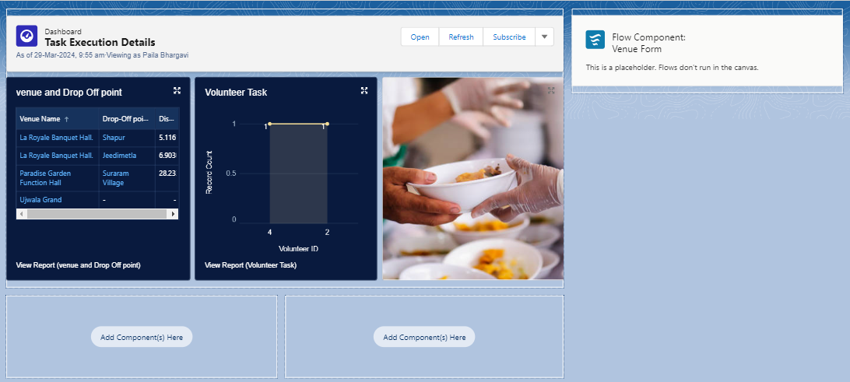

7.Click on Save and Activation, then click on App Default, then Add Assignments.

8.Add FoodConnect App and then Save.

9.FoodConnect Home Page would Look Like this.

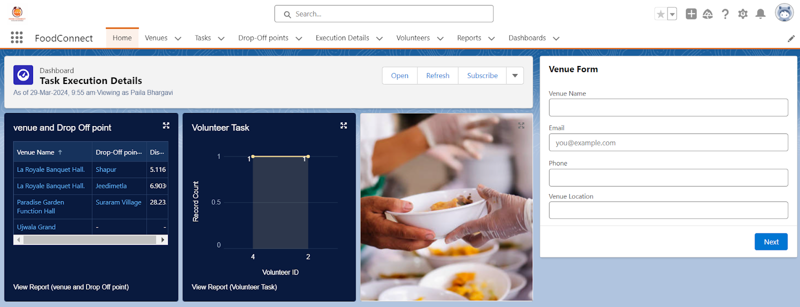

### Conclusion

By leveraging the Salesforce platform, the project successfully established a streamlined and transparent system for managing surplus food donations. Through efficient coordination with volunteers and timely delivery to beneficiaries, the project effectively addressed food insecurity while maximizing the utilization of available resources.

Real-time dashboards and reports provide valuable insights into distribution metrics, volunteer activity, and task progress, supporting data-driven decisions and resource allocation. A customized Home Page streamlines navigation by displaying recent activity, key metrics, and quick links. Overall, Salesforce empowers the project with enhanced organization, accountability, and scalability, making it an effective tool for addressing food distribution challenges and supporting communities in need.